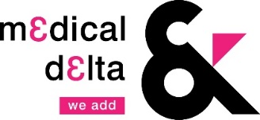

Medical Delta Talent Acceleration Call
proposal format 2021

Please use a maximum of four pages.

Title of the proposal

- Applicants

1.1 Main applicant
State the name, affiliation, position (including % of full-time employment), and contact details of the main applicant.

1.2 Co-applicant(s)
State the name, affiliation, position (including % of full-time employment), and contact details of the co applicant(s).

- Summary
Give a general summary of the project for non-experts using a maximum of 200 words.

- Project description

3.1 Objectives
Describe the objectives of the project and the relation to the foreseen grant application.

3.2 Milestones and deliverables
Give a clear indication of the step-by-step plan and the intended results of the project.

3.3 Fit to Medical Delta
Address the quality and originality of this project, the clinical need of the study, and the added value to a Medical Delta scientific program (an overview of the MD programs can be viewed on our website).

4.3 Project team
Address the fit between the aims and objectives of the project, and the expertise of the project team members.

- Financial planning

Clarify expenditures and summarize the amounts in the table below. For personnel indicate type(s) of position(s), duration and (part)time fraction(s). For materials please specify. If there are other costs, be specific in the description.

Personnel

Materials

Other (be specific here)

Total

